CPE301 – SPRING 2019

MIDTERM 2 (Final)

Student Name: Mohamad Jundi

Student #: 8000321867

Student Email: jundi@unlv.nevada.edu

Primary Github address: https://github.com/MohamedJundi1994/Submission_Midterm2-Final-

Directory:

C:\Users\moham\Documents\School\CPE 301\Repository\CPE_301\Midterms\Midterm 2 (Final)

1. **COMPONENTS LIST AND CONNECTION BLOCK DIAGRAM w/ PINS**

APDS 9960:

USB port => Xplained Mini => 3V => 3oV

=> GND => GND

=> PC4 => SVA

=> PC5 => SCL

ESP32:

USB port => Xplained Mini => 3V => 3V3

=> PD1 (Tx) => Rx

=> PD0 (Rx) => Tx

=> GND => GND

1. **INITIAL/MODIFIED/DEVELOPED CODE OF TASK 1/A**

Code:

#define *F_CPU* 16000000UL

#include <avr/io.h>

#include <util/delay.h>

#include <stdio.h>

#include "i2c_master.h"

#include "9960.h"

#define BAUD 9600

#define BAUDR (*F_CPU*/16/BAUD) - 1

void UART_initialization(); // Function declarations

void Colors(); //

void sen9960_initialization(); //

int sending_char( char info, *FILE* * str); //

*uint16_t* baud_rate = BAUDR; // Int declaration

*uint8_t* red_low, red_high; //

*uint8_t* blue_low, blue_high; //

*uint8_t* green_low, green_high; //

*uint8_t* config; //

*FILE* UART_str = *FDEV_SETUP_STREAM*(sending_char, *NULL* , *_FDEV_SETUP_WRITE*);

char results[256]; // Array results

int main(void)

{

*uint16_t* red = 0; // Declare red

*uint16_t* blue = 0; // Declare blue

*uint16_t* green = 0; // Declare green

i2c_init(); // i2C function call

UART_initialization(); // uart initialization function call

*stdout* = &UART_str; // standard stream

sen9960_initialization(); // initialize 9960 sensor function call

*_delay_ms*(2000); // Give time of 2s

*printf*("AT\r\n"); // AT cmd

*_delay_ms*(3000); // Give time of 3s

*printf*("AT+CWMODE=1\r\n"); // AT cmd mode

*_delay_ms*(3000); // Give time of 3s

*printf*("AT+CWJAP=\"MOE_Wifi\",\"moo123456\"\r\n"); // AT cmd to connect to personal hotspot information

while (1)

{

*_delay_ms*(1500); // Give time of 1.5s

*printf*("AT+CIPMUX=0\r\n"); // AT cmd for CIPMUX

*_delay_ms*(1500); // Give time of 1.5s

*printf*("AT+CIPSTART=\"TCP\",\"api.thingspeak.com\",80\r\n"); // AT cmd to communicate to thingspeak

*_delay_ms*(1500); // Give time of 1.5s

Colors(&red, &blue, &green); // Call colors function

*printf*("AT+CIPSEND=100\r\n"); // AT cmd to send 100 chars

*printf*("GET https://api.thingspeak.com/update?api_key=VBIZQ9TJL06VKSR8&field1=%05u\r\n", red); // Send red value to thingspeak

*_delay_ms*(1500); // Give time of 1.5s

*printf*("AT+CIPMUX=0\r\n"); // AT cmd for CIPMUX

*_delay_ms*(1500); // Give time of 1.5s

*printf*("AT+CIPSTART=\"TCP\",\"api.thingspeak.com\",80\r\n"); // AT cmd to communicate to thingspeak

*_delay_ms*(1500); // Give time of 1.5s

Colors(&red, &blue, &green); // Call colors function

*printf*("AT+CIPSEND=100\r\n"); // AT cmd to send 100 chars

*printf*("GET https://api.thingspeak.com/update?api_key=VBIZQ9TJL06VKSR8&field2=%05u\r\n", blue); // Send blue value to thingspeak

*_delay_ms*(1500); // Give time of 1.5s

*printf*("AT+CIPMUX=0\r\n"); // AT cmd for CIPMUX

*_delay_ms*(1500); // Give time of 1.5s

*printf*("AT+CIPSTART=\"TCP\",\"api.thingspeak.com\",80\r\n"); // AT cmd to communicate to thingspeak

*_delay_ms*(1500); // Give time of 1.5s

Colors(&red, &blue, &green); // Call colors function

*printf*("AT+CIPSEND=100\r\n"); // AT cmd to send 100 chars

*printf*("GET https://api.thingspeak.com/update?api_key=VBIZQ9TJL06VKSR8&field3=%05u\r\n", green); // Send green value to thingspeak

*_delay_ms*(1500); // Give time of 1.5s

}

}

void UART_initialization(void)

{

UBRR0H = baud_rate >> 8; // Setting the baud rate

UBRR0L = baud_rate & 0xFF; //

UCSR0B = ( 1 << RXEN0) | ( 1 << TXEN0) | (1 << RXCIE0); // Receive and transmit are enabled

UCSR0C = (3 << UCSZ00); // Set frame format: 8data, 1stop bit

}

int sending_char(char info, *FILE* *str)

{

while ( !( UCSR0A & ( 1 << UDRE0)) ); // Wait until buffer empty

UDR0 = info; // Data placed into buffer

return 0;

}

void Colors(*uint16_t* *red, *uint16_t* *blue, *uint16_t* *green) // Function used to read the colors for sensor (red, blue and green)

{

i2c_readReg(APDS_WRITE, APDS9960_RDATAL, &red_low, 1);

i2c_readReg(APDS_WRITE, APDS9960_RDATAH, &red_high, 1);

i2c_readReg(APDS_WRITE, APDS9960_GDATAL, &green_low, 1);

i2c_readReg(APDS_WRITE, APDS9960_GDATAH, &green_high, 1);

i2c_readReg(APDS_WRITE, APDS9960_BDATAL, &blue_low, 1);

i2c_readReg(APDS_WRITE, APDS9960_BDATAH, &blue_high, 1);

*red = red_high << 8 | red_low;

*blue = blue_high << 8 | blue_low;

*green = green_high << 8 | green_low;

}

void sen9960_initialization() // Function used to initialize the Sensor only for the RGB, no gesture or proximity used

{

i2c_readReg(APDS_WRITE, APDS9960_ID, &config,1);

if(config != APDS9960_ID_1)

while(1)

{

config = 1 << 1 | 1 << 0 | 1 << 3 | 1 << 4;

}

i2c_writeReg(APDS_WRITE, APDS9960_ENABLE, &config, 1);

config = DEFAULT_ATIME;

i2c_writeReg(APDS_WRITE, APDS9960_ATIME, &config, 1);

config = DEFAULT_WTIME;

i2c_writeReg(APDS_WRITE, APDS9960_WTIME, &config, 1);

config = DEFAULT_PROX_PPULSE;

i2c_writeReg(APDS_WRITE, APDS9960_PPULSE, &config, 1);

config = DEFAULT_POFFSET_UR;

i2c_writeReg(APDS_WRITE, APDS9960_POFFSET_UR, &config, 1);

config = DEFAULT_POFFSET_DL;

i2c_writeReg(APDS_WRITE, APDS9960_POFFSET_DL, &config, 1);

config = DEFAULT_CONFIG1;

i2c_writeReg(APDS_WRITE, APDS9960_CONFIG1, &config, 1);

config = DEFAULT_PERS;

i2c_writeReg(APDS_WRITE, APDS9960_PERS, &config, 1);

config = DEFAULT_CONFIG2;

i2c_writeReg(APDS_WRITE, APDS9960_CONFIG2, &config, 1);

config = DEFAULT_CONFIG3;

i2c_writeReg(APDS_WRITE, APDS9960_CONFIG3, &config, 1);

}

Libraries used:

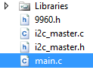

9960.h:

#ifndef APDS_H

#define APDS_H

#include <avr/io.h>

#include "i2c_master.h"

#include "9960.h"

#define APDS_WRITE (0x39 << 1) | 0

#define APDS_READ (0x39 << 1) | 1

/* Debug */

/* APDS-9960 I2C address */

#define APDS9960_I2C_ADDR 0x39

/* Error code for returned values */

#define ERROR 0xFF

/* Acceptable device IDs */

#define APDS9960_ID_1 0xAB

#define APDS9960_ID_2 0x9C

/* Misc parameters */

#define FIFO_PAUSE_TIME 30 // Wait period (ms) between FIFO reads

/* APDS-9960 register addresses */

#define APDS9960_ENABLE 0x80

#define APDS9960_ATIME 0x81

#define APDS9960_WTIME 0x83

#define APDS9960_PERS 0x8C

#define APDS9960_CONFIG1 0x8D

#define APDS9960_PPULSE 0x8E

#define APDS9960_CONFIG2 0x90

#define APDS9960_ID 0x92

#define APDS9960_RDATAL 0x96

#define APDS9960_RDATAH 0x97

#define APDS9960_GDATAL 0x98

#define APDS9960_GDATAH 0x99

#define APDS9960_BDATAL 0x9A

#define APDS9960_BDATAH 0x9B

#define APDS9960_POFFSET_UR 0x9D

#define APDS9960_POFFSET_DL 0x9E

#define APDS9960_CONFIG3 0x9F

/* Bit fields */

#define APDS9960_PON 0b00000001

#define APDS9960_AEN 0b00000010

#define APDS9960_PEN 0b00000100

#define APDS9960_WEN 0b00001000

#define APSD9960_AIEN 0b00010000

#define APDS9960_PIEN 0b00100000

#define APDS9960_GEN 0b01000000

#define APDS9960_GVALID 0b00000001

/* On/Off definitions */

#define OFF 0

#define ON 1

/* Acceptable parameters for setMode */

#define POWER 0

#define AMBIENT_LIGHT 1

/*#define PROXIMITY 2*/

#define WAIT 3

#define AMBIENT_LIGHT_INT 4

#define ALL 7

/* LED Drive values */

#define LED_DRIVE_100MA 0

#define LED_DRIVE_50MA 1

#define LED_DRIVE_25MA 2

#define LED_DRIVE_12_5MA 3

/* LED Boost values */

#define LED_BOOST_100 0

#define LED_BOOST_150 1

#define LED_BOOST_200 2

#define LED_BOOST_300 3

/* Default values */

#define DEFAULT_ATIME 219 // 103ms

#define DEFAULT_WTIME 246 // 27ms

#define DEFAULT_PROX_PPULSE 0x87 // 16us, 8 pulses

#define DEFAULT_POFFSET_UR 0 // 0 offset

#define DEFAULT_POFFSET_DL 0 // 0 offset

#define DEFAULT_CONFIG1 0x60 // No 12x wait (WTIME) factor

#define DEFAULT_LDRIVE LED_DRIVE_100MA

#define DEFAULT_PGAIN PGAIN_4X

#define DEFAULT_AGAIN AGAIN_4X

#define DEFAULT_AILT 0xFFFF // Force interrupt for calibration

#define DEFAULT_AIHT 0

#define DEFAULT_PERS 0x11 // 2 consecutive prox or ALS for int.

#define DEFAULT_CONFIG2 0x01 // No saturation interrupts or LED boost

#define DEFAULT_CONFIG3 0 // Enable all photodiodes, no SAI

#define DEFAULT_GLDRIVE LED_DRIVE_100MA

#define DEFAULT_GWTIME GWTIME_2_8MS

void apds_init();

/*void readColor();*/

#endif

I2c_master.c:

#ifndef *F_CPU*

#define *F_CPU* 16000000UL

#endif

#include <avr/io.h>

#include <util/twi.h>

#include "i2c_master.h"

#define F_SCL 100000UL // SCL frequency

#define Prescaler 1

#define TWBR_val ((((*F_CPU* / F_SCL) / Prescaler) - 16 ) / 2)

void i2c_init(void)

{

TWBR = (*uint8_t*)TWBR_val;

}

*uint8_t* i2c_start(*uint8_t* address)

{

// reset TWI control register

TWCR = 0;

// transmit START condition

TWCR = (1<<TWINT) | (1<<TWSTA) | (1<<TWEN);

// wait for end of transmission

while( !(TWCR & (1<<TWINT)) );

// check if the start condition was successfully transmitted

if((TWSR & 0xF8) != *TW_START*){ return 1; }

// load slave address into data register

TWDR = address;

// start transmission of address

TWCR = (1<<TWINT) | (1<<TWEN);

// wait for end of transmission

while( !(TWCR & (1<<TWINT)) );

// check if the device has acknowledged the READ / WRITE mode

*uint8_t* twst = *TW_STATUS* & 0xF8;

if ( (twst != *TW_MT_SLA_ACK*) && (twst != *TW_MR_SLA_ACK*) ) return 1;

return 0;

}

*uint8_t* i2c_write(*uint8_t* data)

{

// load data into data register

TWDR = data;

// start transmission of data

TWCR = (1<<TWINT) | (1<<TWEN);

// wait for end of transmission

while( !(TWCR & (1<<TWINT)) );

if( (TWSR & 0xF8) != *TW_MT_DATA_ACK* ){ return 1; }

return 0;

}

*uint8_t* i2c_read_ack(void)

{

// start TWI module and acknowledge data after reception

TWCR = (1<<TWINT) | (1<<TWEN) | (1<<TWEA);

// wait for end of transmission

while( !(TWCR & (1<<TWINT)) );

// return received data from TWDR

return TWDR;

}

*uint8_t* i2c_read_nack(void)

{

// start receiving without acknowledging reception

TWCR = (1<<TWINT) | (1<<TWEN);

// wait for end of transmission

while( !(TWCR & (1<<TWINT)) );

// return received data from TWDR

return TWDR;

}

*uint8_t* i2c_transmit(*uint8_t* address, *uint8_t*\* data, *uint16_t* length)

{

if (i2c_start(address | I2C_WRITE)) return 1;

for (*uint16_t* i = 0; i < length; i++)

{

if (i2c_write(data[i])) return 1;

}

i2c_stop();

return 0;

}

*uint8_t* i2c_receive(*uint8_t* address, *uint8_t*\* data, *uint16_t* length)

{

if (i2c_start(address | I2C_READ)) return 1;

for (*uint16_t* i = 0; i < (length-1); i++)

{

data[i] = i2c_read_ack();

}

data[(length-1)] = i2c_read_nack();

i2c_stop();

return 0;

}

*uint8_t* i2c_writeReg(*uint8_t* devaddr, *uint8_t* regaddr, *uint8_t*\* data, *uint16_t* length)

{

if (i2c_start(devaddr | 0x00)) return 1;

i2c_write(regaddr);

for (*uint16_t* i = 0; i < length; i++)

{

if (i2c_write(data[i])) return 1;

}

i2c_stop();

return 0;

}

*uint8_t* i2c_readReg(*uint8_t* devaddr, *uint8_t* regaddr, *uint8_t*\* data, *uint16_t* length)

{

if (i2c_start(devaddr)) return 1;

i2c_write(regaddr);

if (i2c_start(devaddr | 0x01)) return 1;

for (*uint16_t* i = 0; i < (length-1); i++)

{

data[i] = i2c_read_ack();

}

data[(length-1)] = i2c_read_nack();

i2c_stop();

return 0;

}

void i2c_stop(void)

{

// transmit STOP condition

TWCR = (1<<TWINT) | (1<<TWEN) | (1<<TWSTO);

}

I2c_master.h:

#ifndef I2C_MASTER_H

#define I2C_MASTER_H

#define I2C_READ 0x01

#define I2C_WRITE 0x00

void i2c_init(void);

*uint8_t* i2c_start(*uint8_t* address);

*uint8_t* i2c_write(*uint8_t* data);

*uint8_t* i2c_read_ack(void);

*uint8_t* i2c_read_nack(void);

*uint8_t* i2c_transmit(*uint8_t* address, *uint8_t*\* data, *uint16_t* length);

*uint8_t* i2c_receive(*uint8_t* address, *uint8_t*\* data, *uint16_t* length);

*uint8_t* i2c_writeReg(*uint8_t* devaddr, *uint8_t* regaddr, *uint8_t*\* data, *uint16_t* length);

*uint8_t* i2c_readReg(*uint8_t* devaddr, *uint8_t* regaddr, *uint8_t*\* data, *uint16_t* length);

void i2c_stop(void);

#endif // I2C_MASTER_H

1. **DEVELOPED MODIFIED CODE OF TASK 2/A from TASK 1/A**

All code and libraries are in number 1.

1. **SCHEMATICS**

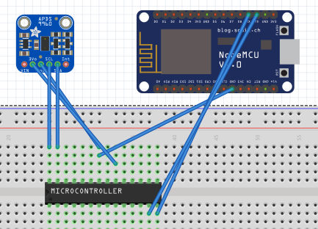

1. **SCREENSHOTS OF EACH TASK OUTPUT (ATMEL STUDIO OUTPUT)**

Atmel Studio Output and Arduino Serial Port Output:

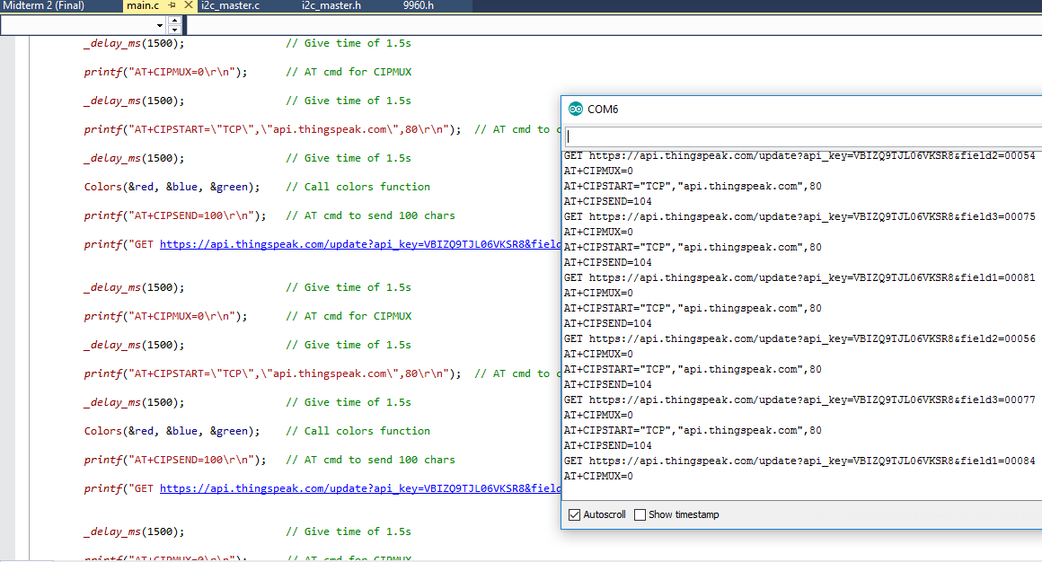

Thingspeak charts of Red, Blue and Green:

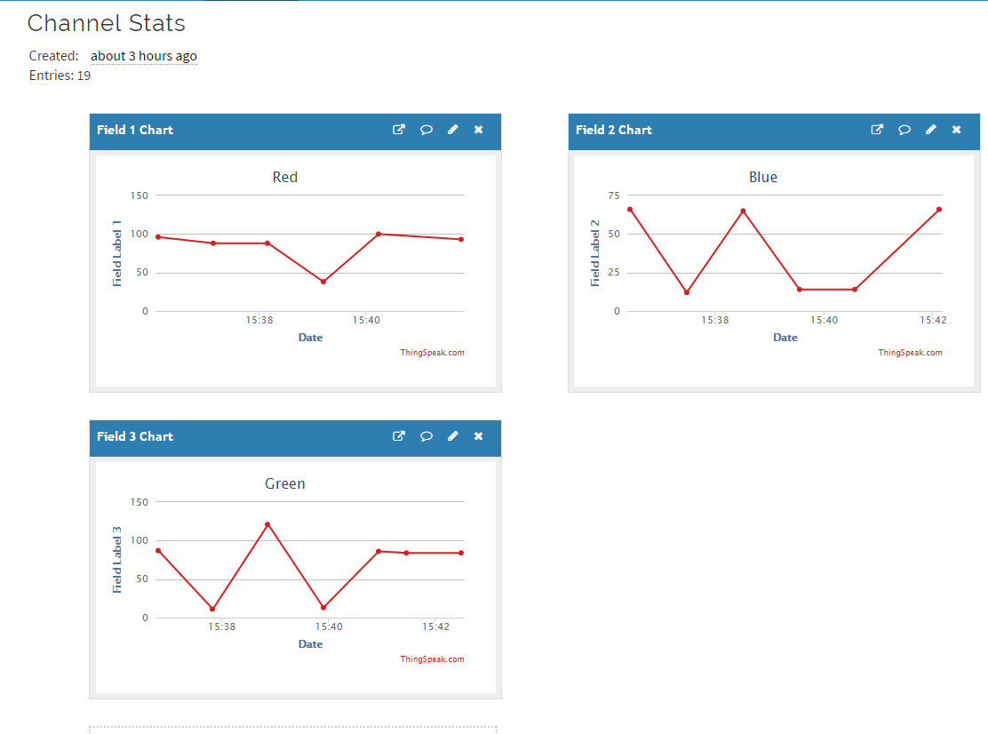

1. **SCREENSHOT OF EACH DEMO (BOARD SETUP)**

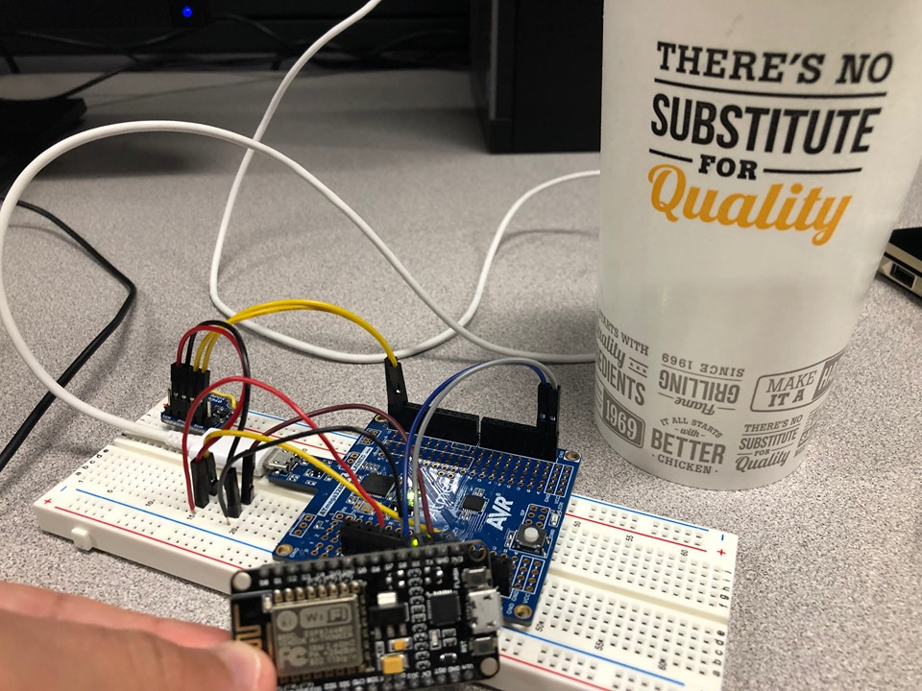

1. **VIDEO LINKS OF EACH DEMO**

LINK: <https://www.youtube.com/watch?v=33WFjyIlcmw&feature=share&fbclid=IwAR0GkQkyGIh0dnR5kzf-DM9BQZzXoNfnIMcAjDZi6olfJkvblBmh6JaHNrU>

1. **GITHUB LINK OF THIS DA**

LINK: https://github.com/MohamedJundi1994/Submission_Midterm2-Final-

“This assignment submission is my own, original work”.

MOHAMAD JUNDI